***Final IBP report.***

| Section | Word guide (Approx.) | Person |
| --- | --- | --- |
| Executive summary, conclusion, title page, table of contents, appendix and editing | 300 (Intro & conclusion) | Manish |
| Business details  Legal issues (EDI, IP) | 350 | Kathleen |
| Business Model  And prototype | 450 | Max |
| Target Market | 450 | Amna |
| Marketing Strategy | 450 | Gianni |
| Financial Viability  Cost structure/ value?  Cost benefit (graph in report, details in appendix)  SWOT  Competitor analysis | 450 | Emma |

**Total Word Count: 2477**

**Report** By Gianni, Max, Emma, Kathleen, Manish and Kathleen [**Group 1**]

**Executive Summary**

Within the process of developing Planning Pal, significant application has gone into empathising and researching the major organisational deficiencies faced by students, in order to design a tangible service that resolves these fundamental issues whilst engendering additional gains in an integrative, low expense and feasible manner.

**Business Detail**

Time management is often a skill that many university students struggle with. To overcome this problem, our team has devised an intangible service called Planning pal. The service comes in the form of an online organiser fit with various features designed to enhance a student’s ability to manage their time effectively. Thus, enhancing their overall organisational ability and skills.

**Legal Issues**

Three legal issues that would be considered in the event that the business idea would be developed in real life include, intellectual property laws, contracts within the business and laws regarding consumer protection.

Intellectual property laws are a legal issue that our team would come across and consider when developing our idea in real life. Planning pal is an online organiser and although there are already several online organisers available in the market, it has features that have not been presented in the market before. For instance, Planning pal shares similarities to an online organiser called Dayviewer, in that it also has a scheduling and task feature (Dayviewer n.d.). However, Dayviewer lacks such similar feature as, Future Friend or a reward system. Hence, the process of applying for patents would be strongly considered an important consideration, in order to gain protection for our product’s unique features (Patents Act 1990).

Moreover, our team would consider the types of contracts to be made within the business. Specific details concerning contracts with internal and external stakeholders would be discussed and the execution of these contracts would follow Australian contract law. Since our team plans to partner with other educational and commercial organisations, we would consider creating written partnership agreements and formulate whether the partnership to be formed should be a normal partnership, a limited partnership or an incorporated partnership.

Laws regarding consumer protection would also be a legal issue to be considered. There are various laws that have been created to protect consumers and these all fall under the Australian Consumer Law. In developing Planning Pal, our team would ensure that our practices are truthful and not misleading in any way. For instance, when presenting our idea to potential partnerships or consumers, the information presented will be concise and careful time and appropriate procedure taken in order to avoid any misconduct through miscommunication of our product.

**Business Model**

The Planning Pal is an integrative organiser, operative both online and offline that helps the user effectively manage their time. During the initial stages of our product design and conception, we identified that a student’s lack of organisational skill can lead to poor time management. Which can result in high levels of stress and other health related consequences. We have identified a gap in the market and intend to fill this gap while also elevating the everyday lifestyle of students.

A problem universal to all students is the effective utilisation of organisational skills to manage their time effectively, this can often result in a student experiencing high levels of stress. The Planning Pal is a system designed to alleviate the negative impact of stress and make the user feel more in control.

The product has multiple features which are designed to engender various pain relievers and gain creators upon the stakeholder, that reduce the impact of stress and increase the users’ organisational ability. From a simplified exterior perspective, Planning Pal is a timetable generated after the user inputs all of their commitments, activities and deadlines into the system. The timetable is a visual representation of the users’ various responsibilities and enables the user to proficiently organise their study routine, facilitating a potential improvement in a user’s amount and ability to enjoy their spare time. Hence, even on a superficial level, Planning Pal provides a viable and desirable service that improves the overall livelihood of the user - the overwhelmed student.

Moreover, when examining the corresponding features of Planning Pal, it becomes clear that the desirability, feasibility and viability of the service is superior than any existing singular organisational tools. As among others, Planning Pal’s flagging system sets reminders for due dates and highlights the urgency of the task contingent on the user’s preferences and academic information shared with the system upon sign-up, ensuring that the user is constantly aware of their academic and non-academic responsibilities, with additional emphasis on advance preparation. Which, conjuncted with the unique and corresponding ‘Future Friend’ feature that re-allocates future timeslots and alerts the user of the consequential implications of an incomplete scheduled task, creates a viable resolution to ensuring a succinct and sustained study lifestyle. In addition, the ‘AppBlocka’ feature bestows another layer of desirability and viability, as its functions address the most predominant predicament facing students upon undertaking a successful study routine - procrastination. It does so by blocking out the primary cause for procrastination, being persistent application use. Through the immobilisation of specified or all applications, elected upon the user’s discretion. Lastly, a reward system is inplace to incentivise the user to stay focused. Planning Pal will partner with retailers such as General Pants, Glue and Platypus, that appeal to our target market, to provide users with discounts or a special deals upon completion of tasks/chain of tasks. Thus, conferring additional desirability to initially employ and maintain its utilisation amongst users. [See appendix for graphic detail]

Hence, the Planning Pal bestows value within its instigation of an enhanced organisational routine and experience, in order to facilitate a comprehensive lifestyle absent of overwhelming stress and pressure, amongst its target market.

**Target Market**

Targeting a market allows us to focus on a specific group of stakeholders whose demands align with the needs our product is trying to fulfil. Our aim with our product is to target 70% of first year university students, as majority of first year students experience deficiencies with managing their time effectively.

In determining our specific target market, we ascertained from our empathy conversations that many first year students struggle with maintaining a balance between university and work life due to the immense transitional difference in learning environment and workload from high school to university. It was clear that, in addition to the challenge of an increased workload students were introduced to extra-curricular commitments instigated by the inflow of a novel social environment, led them to inefficiently managing their time, thus, attributing to greater levels of stress and mental health issues when completing tasks.

We also learnt through our empathy conversations that due to students having busy schedules they often forgot about university tasks and commitments, conveying the independent learning style of university is divergent and requires adjusting to, as they are accustomed to receiving constant reminders of due dates in high school. Therefore, we collated all the information from our empathy conversations, resulting in our target market being focused on an estimate of 70% of first year students whom we believe will be struggling with inconsistent time management skills, as we believe our product will allow them to structure out their lives leading to efficient organisation. Our estimate of 70% comes from the results of empathy conversations as well as our educated predictions that many first year university students would experience a lack of balance within their university and work lives.

Behaviourally, our target market will consist of students with relatively poor organisational skills. Due to poor organisational skills, these stakeholders would not have any well-defined goals or structured task schedules attributing to inadequate time management. Furthermore, our product has the potential to be targeted towards university students who live away from home. Thus, allowing the potential of market diversification, as these students are constantly trying to achieve financial stability which may often defer their focus from their university tasks. Differentiating the market into specific groups will allow us to ‘reveal points of differentiation’ which (Dufault, Harold, Koenig, Mcalexander 2016) claims will allow a business to develop the most effective positioning strategies as targeting the market is one of the most propelling contributions to a business. Hence, Planning Pal through the utilisation of organisational features, as - reminders and timetables, in feasible formats, our proposed target market will ultimately enhance their overall organisational skills, therefore forging a healthier routine within their lifestyle.

**Marketing Strategy**

Firstly, Panning Pal is an intangible service that will be distributed to students for free. Our service is initially free for any school student to use. However, to get more use and access to better features to our service, a subscription fee is introduced for those students at a low price point. Currently the price point is $4.95 subscription per semester. To reach our target market - students, partnering with UTS is an obvious choice to aid in promoting our service initially. To reach other students, we are willing to partner with schools, TAFE organisations and other Universities in order to promote our service. Word of mouth and subsidiary funds dedicated towards targeted advertising, will provide secondary means of promoting our service to educational organisations and the students that attend them.

When emerging into the market, Planning Pal intends to gradually build up a customer base as over targeting can be disastrous to our service and can result in consequences counter to those desired. This idea of cementing a dedicated user base is concluded by Fulgoni, G. (2018) as extremely beneficial marketing ideal for new products. Advertising will be targeted more towards mobile promotion in applications such as mobile gaming and mobile shopping among the many smart decisions presented by (Bakopoulos et al. 2017). In terms of our reward system. In order to encourage use of our service, we are willing to partner with various retailers, e.g. General Pants Co., to provide our users with such rewards as a discount of $50 off next purchase or a 10% discount with a code.

The distribution of our service is facilitated feasibly through our website, where users create an account and specify their personal criteria that corresponds with the purposes they require, our service then generates a personalised planner specific of the user’s tasks and organisational shortcomings. Furthermore, Planning Pal will go further than just a simple website platform, it will also be designed to fit the needs of mobile users, in order for the user to have an experience integrated towards their lifestyle. As encouraged by results from Bakopoulos et al. (2017), Planning Pal will be a product in constant use to encourage users to utilise its maximum potential for each user and their lifestyle.

**Financial Viability**

**COST STRUCTURE**

*Value driven cost structure*

Planning Pal will focus it’s effort into creating perceived value from customers. Aspects of a value driven cost structure that will be relevant to Planning Pal are:

* High levels of personalisation with an effort to customise each service to perfectly fit an individuals’ needs.
* Sleek and modern design aimed creating a luxury atmosphere to the customer, indicating high levels of value
* Aspects that allow a user to be held accountable - this creates long term value in the customer’s eye
* Close and ongoing relationship to customers - support systems, and quarterly check-ins with customers

Woodruff (1997) has noted that a firm continually focused on building value for the customer will establish and maintain long term competitive advantage.

**Cost benefit analysis**

(See Appendix 3.)

*Explaining revenue in Year One*

**Number of clients**

Number of enrolled students in business faculty = 10929

70% interested in improving time management = 7700

50% of these willing to purchase product = 3900

of these:

10% interested in premium = 390

remaining 40% interested in base subscription = 3500

**Revenue**

Base Subscription

12 month subscription

$5 per month

= 12 * $5 * Number of potential clients

= $210,000

Premium Subscription

12 month subscription

$10 per month

= 12 * $10 * number of clients

= $46,800

TOTAL: $256,800

**SWOT ANALYSIS**

| STRENGTHS   * Personalised * Unique (lack of competitors) * Flexible * Low ongoing operational costs | WEAKNESSES   * Low customer loyalty * High startup costs * Volatile revenue stream * Easy to avoid reminders * lack of accountability in non premium version |
| --- | --- |
| OPPORTUNITIES   * To connect with business interested in offering rewards * Expansion into other markets - Schools, TAFEs, other tertiary institutions | **T**HREATS   * Similar system runs internally through the university * Many competitors provide the service free, as they are associated with a university or with Apple |

**COMPETITOR ANALYSIS**

|  | **Competitor One - GoConqr.** | **Competitor Two - SelfControl** | **Competitor Three - Calendar synced with UTS timetable (UTS)** |
| --- | --- | --- | --- |
| **FEATURES** | * Website that lets you build a study schedule * Ability to create, manage and track tasks * Can track time spent on each subject * cloud to upload work/files | Mac only application that allows users to blacklist and whitelist websites, aimed at increasing productivity | * Synced UTS timetable to Calendar application (on MAC or windows) * shows rooms * can set reminders/alarms |
| **KEY COMPETITIVE ADVANTAGE** | - allows a user to customise and track their study habits, which is a unique key activity | Free to install, and simple to use at any time | Can be easily integrated into a users existing calendar |
| **TARGET MARKET** | High School and University Students - ‘GoConqr’ is based only on academic study | All Mac users - does not focus solely on students, but on all individuals looking to improve productivity | UTS students and staff only. All Faculties. |
| **REVENUE STREAMS** | * Subscription based revenue stream * Advertisement as secondary stream | * Advertising is the sole revenue stream * No subscription | No revenue streams |
| **PRICING** | Two levels of subscription - Basic and Premium. Basic is free. Premium is $3.75USD a month | Free to download and use | Free to download when UTS timetable is generated |
| **WEAKNESSES** | - can only be used to track study, rather than multiple aspects of a users life (job, extracurricular etc.) | * does not allocate specific tasks to be completed * must be manually turned on * no planning element that would allow a user to suggest when SelfControl should be in use * easily to turn off/ avoid the software | * can only be used to see scheduled events (lectures, tutorials, practicals etc.) * would need to manually add other events * no “study time” aspect |

**Conclusion**

Therefore, Planning Pal withstows a unique and practical service that identifies and addresses the needs and desires associated within the student market undertaking a form of tertiary studies. Within the various features of the Planning Pal system, meticulous effort and deliberation of the target market, marketing strategy and financial viability has gone into producing a viable, desirable and feasible product that services the organisational challenges revolving around a balanced academic and social lifestyle.Whilst, careful consideration of legal issues was put in place to ensure all functions of the product are able to operate and unique features remain distinct to Planning Pal, through the application of IP legislation. Hence, the Planning Pal service aims to propel a student’s organisational habits into the future through unique and pertinent features that ultimately elevate the time management and organisational processes of its customers.

**Reference List**

Bakopoulos, V. Baeonello, J. Briggs, R. 2017. ‘How Brands Can Make Smarter Decisions in Mobile Marketing’, *Journal of Advertising Research,* Vol. 57, No. 4, pp.447-461.

Dayviewer Ltd. n.d., viewed 31 May 2018, <<https://www.dayviewer.com/>>.

Fulgoni, G. 2018, ‘Are You Targeting Too Much? Effective Marketing Strategies for Brands’ *Journal of Advertising Research,* Vol. 58, No. 1, pp. 8-11.

Patents Act 1990 (Cth).

Woodruff, R. (1997). Customer value: The next source for competitive advantage. Journal of the Academy of Marketing Science, 25(139).

**Appendix**

**1.**

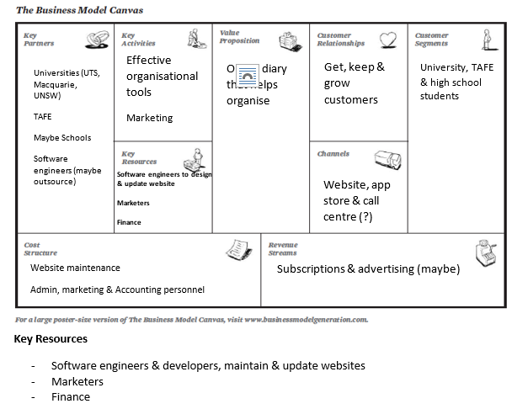

**2**.

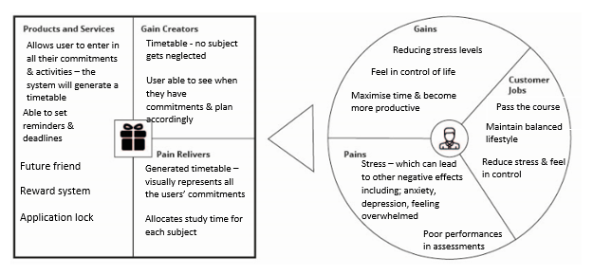

**3.**

